|  |  |  |
| --- | --- | --- |
|  |  |  |

**ARAB ACADEMY FOR SCIENCE, TECHNOLOGY AND MARITIME TRANSPORT**

***College of Computing and Information Technology***

Department of  
**Computer Science and Software Engineering**

CCIT Graduation Project

**Gamified E-learning System for Kids**

By:

* *Kirolos Khamis 17100652*
* *Boula Nessim 17100676*
* *Ibrahim Samy 17100648*
* *Hesham Mousa 17101452*
* *Mohamed Ali 17100677*
* *Ayten Elsayed 17101874*

*Supervised by*

***Dr. Nada Hany***

*Date of examination*

*14/7/2021*

ABSTRACT

Our graduation project is mainly about gamified E-learning for kids to fulfils their thirst for knowledge and offers online content that can be delivered for children at anywhere, and anytime. Also, teachers can create contents and, Parents can supervise their children performance.

Students are to keep track in their courses and hall courses and check availability and obtain knowledge through E-learning systems rather than manually teaching and learning. Parents are for monitoring all children types courses services and their academic performance. Parents can access to all system functionalities without any restrictions of their children. Teachers can only mange the contents of the course and upload all of the resources and materials.

Our website contains a classroom that will help teacher to upload materials for student and resources that enable student to access it at any time which is very important to enhance the performance of the student on their study.

يتمحور مشروع التخرج الخاص بنا بشكل أساسي حول التعليم الإلكتروني المحبب للأطفال لإشباع تعطشهم للمعرفة ويقدم محتوى عبر الإنترنت يمكن تسليمه للأطفال في أي مكان وفي أي وقت. أيضًا ، يمكن للمدرسين إنشاء محتويات دراسيه ويمكن للآباء مراقبة أطفالهم.

يتعين على الطلاب متابعة المواد الدراسيه وقاعات المواد الدراسيه والتحقق من توفرها والحصول على المعرفة من خلال أنظمة التعلم الإلكتروني بدلاً من التدريس والتعلم يدويًا. على أولياء الأمور مراقبة جميع أنواع خدمات المواد للأطفال وأدائهم الأكاديمي. يمكن للوالدين الوصول إلى جميع وظائف النظام دون أي قيود على أطفالهم. يمكن للمدرسين فقط إدارة محتويات المواد الدراسيه وتحميل جميع الموارد والمواد الدراسيه.

يحتوي موقعنا على فصل دراسي يساعد المعلم في تحميل المواد الدراسيه للطلاب والموارد التي تمكن الطالب من الوصول إليها في أي وقت وهو أمر مهم للغاية لتحسين أداء الطالب في دراستهم.

Acknowledgment

We would like to express our deep gratitude and special thanks to Dr. Nada Hany for her continuous support, patient guidance, enthusiastic encouragement, and useful critiques of this work, in addition to giving us useful constructive recommendations on this project.

Without her advice and assistance in keeping our progress consistent and helping us to understand all challenges and the market requirements throughout the development period of this project the work would not have been possible.

Table of Contents

List of figures 3

1 Introduction 5

1.1 purpose 5

1.2 Project Scope 5

1.3 product Features 5

1.3.1 Feature for teacher 6

1.3.2 Feature for student 6

1.3.3 Feature for parent 6

1.4 Project objective 6

2 BACKGROUND AND LITERATURE REVIEW 8

2.1 THEORETICAL BACKGROUND 8

2.1.1 What is Gamification? 8

2.1.2 Gamification Elements for our learning System 8

2.1.3 Mapping Between the Big 5 and Hexad 10

2.1.4 Mapping Between Hexad and Game Elements 11

2.1.5 Gamification User Types Hexad framework 11

2.2 IMPLEMENTATION TECHNOLOGY 12

2.2.1 User Interface 12

2.2.2 Software Interface 12

2.2.3 Hardware Interface 13

2.2.4 Used Technologies 13

3 Requirements Gathering 14

3.1 user classes and characteristics 14

3.2 Functional Requirement 14

3.2.1 Functional requirement of teacher 14

3.2.2 Functional requirement of Student 15

3.2.3 Functional requirement of parents 17

3.3 Nonfunctional Requirement 18

4 SOFTWARE DIAGRAMS 20

4.1 Structural Diagrams 20

4.1.1 Entity Relational Diagram (ERD) 20

4.1.2 Class Diagram 21

4.1.3 Deployment diagram 22

4.2 Behavioral Diagrams 23

4.2.1 Use Case 23

4.2.2 State Chart 26

4.2.3 Activity Diagram 28

4.2.4 Sequence Diagram 47

5 Product Implementation 62

6 FUTURE WORK AND CONCLUSION 63

6.1 Future work: 63

6.2 Conclusion 63

List of figures

Figure 4.1 1 ERD 20

Figure 4.1 2 Class Diagram 21

Figure 4.1 3 Deployment Diagram 22

4.2 1(use case) 23

4.2 2 (use case cont(1)) 24

4.2 3(use cse cont(2)) 25

4.2 4(state chart) 26

4.2 5(state chart cont(1)) 27

4.2 6(state chart cont(2)) 27

4.2 7(Activity diagram) 28

4.2 8(Activity diagram cont(1)) 29

4.2 9(Actvity diagram cont(2)) 30

4.2 10 (Activity diagram cont(3)) 31

4.2 11(Activity diagram cont(4)) 32

4.2 12(Activity diagram cont(5)) 33

4.2 13(Activity diagram cont(6)) 34

4.2 14(Activity Diagram cont(7)) 35

4.2 15(Activity Diagram cont(8)) 36

4.2 16(Activity diagram cont(9)) 37

4.2 17(Activity diagram cont(10)) 38

4.2 18(Activity Diagram cont(11)) 39

4.2 19(Activity Diagram cont(12)) 40

4.2 20(Activity Diagram cont(13)) 41

4.2 21(Activity Diagram cont(14)) 42

4.2 22(Activity Diagram cont(15)) 43

4.2 23(Activity diagram Cont(16)) 44

4.2 24(Activity Diagram Cont(17)) 45

4.2 25(Activity Diagram cont(18)) 46

4.2 26(Sequence Diagram) 47

4.2 27(Sequence Diagram cont(1)) 48

4.2 28(Sequence Diagram cont(2)) 49

4.2 29(Sequence Diagram cont(3)) 50

4.2 30(sequence Diagram cont(4)) 51

4.2 31(Sequence diagram cont(5)) 52

4.2 32(Sequence Diagram cont(6)) 53

4.2 33(Sequence Diagram cont(7)) 54

4.2 34(Sequence Diagram cont(8)) 55

4.2 35(Sequence diagram cont(9)) 56

4.2 36(Sequence Diagram cont(10)) 57

4.2 37(Sequence Diagram cont(11)) 58

4.2 38(Squence Diagram cont(12)) 59

Chapter One

# Introduction

## purpose

Nowadays the parents are very busy, so that they cannot observance their kids and their activities a properly and frequently. In addition, many of students face some problems on understanding important concepts in the class properly. Besides, there are lots of students who are interesting to learn but they faced a huge problem that cannot get enough resources or accessibility. So, Our E-learning System for kids is going to be implemented for E-learning will automate the major operations of the learning. Students are to keep track in their course and hall courses and check availability. Parents are for monitoring all child types courses services and their academic performance. Parents can access to all system functionalities without any restrictions of their children. Students can access to all system functionalities with limited restrictions. Teachers can only mange the contents of the course and upload all of the resources and materials.

## Project Scope

Learning System for kids is an education via the Internet, network, or standalone computer. Learning System for kids is basically the network-enabled convey of skills and knowledge. It may help to studying perfectly in a very short time, It will help a student to know the management of passed year perfectly. It also helps him /her by gamification that It can also be defined as a set of activities and processes to solve problems by using or applying the characteristics of game elements. game like elements have been used to Educate.

* An ability to interact teacher and student on classroom.
* An ability for parent to follow their children activity and grades.
* An ability to use tools like gamification to facilitate learning for kids.
* An ability for student to view grade and course uploaded of their exams easily.
* An ability for teacher to update their course and result on classroom or website.
* An ability for chatbot to answer a specific question.

## product Features

### Feature for teacher

* can register on the system
* can login into their account after registration in the system?
* Create classroom for courses.
* Assign classwork for student.
* can review the interaction of students to the website.
* set result of student.
* Chat bot to answer specific question to the student, parent, if there is no answer all the actors can interact with each other.

### Feature for student

* can create free accounts.
* System is responsible for choosing the Gamification method for students by making a survey to ask about their personalities type.
* login to his account
* Have access to upload their classwork.
* Showing the submission status of assignments.
* View their grades.
* View the schedule.
* Students have the ability to create favorite folders.
* Review the details including (Rank, Grades, Registered courses, and Feedback) of students.
* chat bot to answer specific questions to the students.
* Notifications of deadlines for students.
* Students may submit a Questionnaire at the end of courses**.**

### Feature for parent

* can register free accounts.
* can login into their account after registration in the system?
* Review the details including (Rank, Grades, Registered courses, and Feedback) of their children.
* interact with teachers and the system.

## Project objective

It is a statement that defines the specific objective that the project aims to achieve. The main objective of our project is to Learning System for kids refers to using electronic applications and processes to learn. includes all forms of electronically supported learning and teaching. The project objective also includes parent to follow their student grades and teacher to interact with their student, and some gamification to help him/her easy learning.

Chapter Two

# BACKGROUND AND LITERATURE REVIEW

## THEORETICAL BACKGROUND

### ****What is Gamification?****

**Gamification** is the application of game-design elements and game principles in non-game contexts. It can also be defined as a set of activities and processes to solve problems by using or applying the characteristics of game elements.

Games and game like elements have been used to Educate, Entertain and Engage for thousands of years. Some classic game elements are Points, Badges, and Leaderboards.

* **Points** are used as visual identifiers of progress in sports, reward cards and video games.
* **Badges** display achievement, whether from service in the military or a gold star on school report card.
* **Leaderboards** are used across sports, sales teams, and in general life to present competitive placement.

#### Big Five Personality Traits

The most used model of personality in academic psychology. Those five personality traits are abbreviated as OCEAN, which are:

* **Openness**: known as curious and open to new ideas.
* **Conscientiousness**: known as organized and systematic.
* **Extraversion**: known as being outgoing and enjoy social situations.
* **Agreeableness**: known as being tolerant and trusting.
* **Neuroticism**: known as being anxious and moody.

### Gamification Elements for our learning System

#### General

* On-boarding / Tutorials: No one uses manuals anymore! Help people get used to your system with a nice tutorial or a gentle introduction on how everything works.
* Fixed Reward Schedule: Reward people based on defined actions and events. First activity, level up, progression. Useful during on-boarding and to celebrate milestone events.
* Time Pressure: Reducing the amount of time people have to do things can focus them on the problem. It can also lead to different decisions.
* Progress / Feedback: Progress and feedback come in many forms and have many mechanics available. All User Types need some sort of measure of progress or feedback, but some types work better than others.

#### Personalized

* **Openness**: Access (**Philanthropists**), Branching Choices **(Free Spirit)**
* **Conscientiousness**: Access (**Philanthropists**), Certificates **(Achiever)**, Badges/Leaderboards **(Player)**
* **Extraversion**: Access (**Philanthropists**), Teams **(Socializer),** Branching Choices **(Free Spirit)**
* **Agreeableness**: Access (**Philanthropists**), Social Status **(Socializer)**
* **Neuroticism**: Branching Choices **(Free Spirit),** Anonymity **(Disruptor)**

### Mapping Between the Big 5 and Hexad

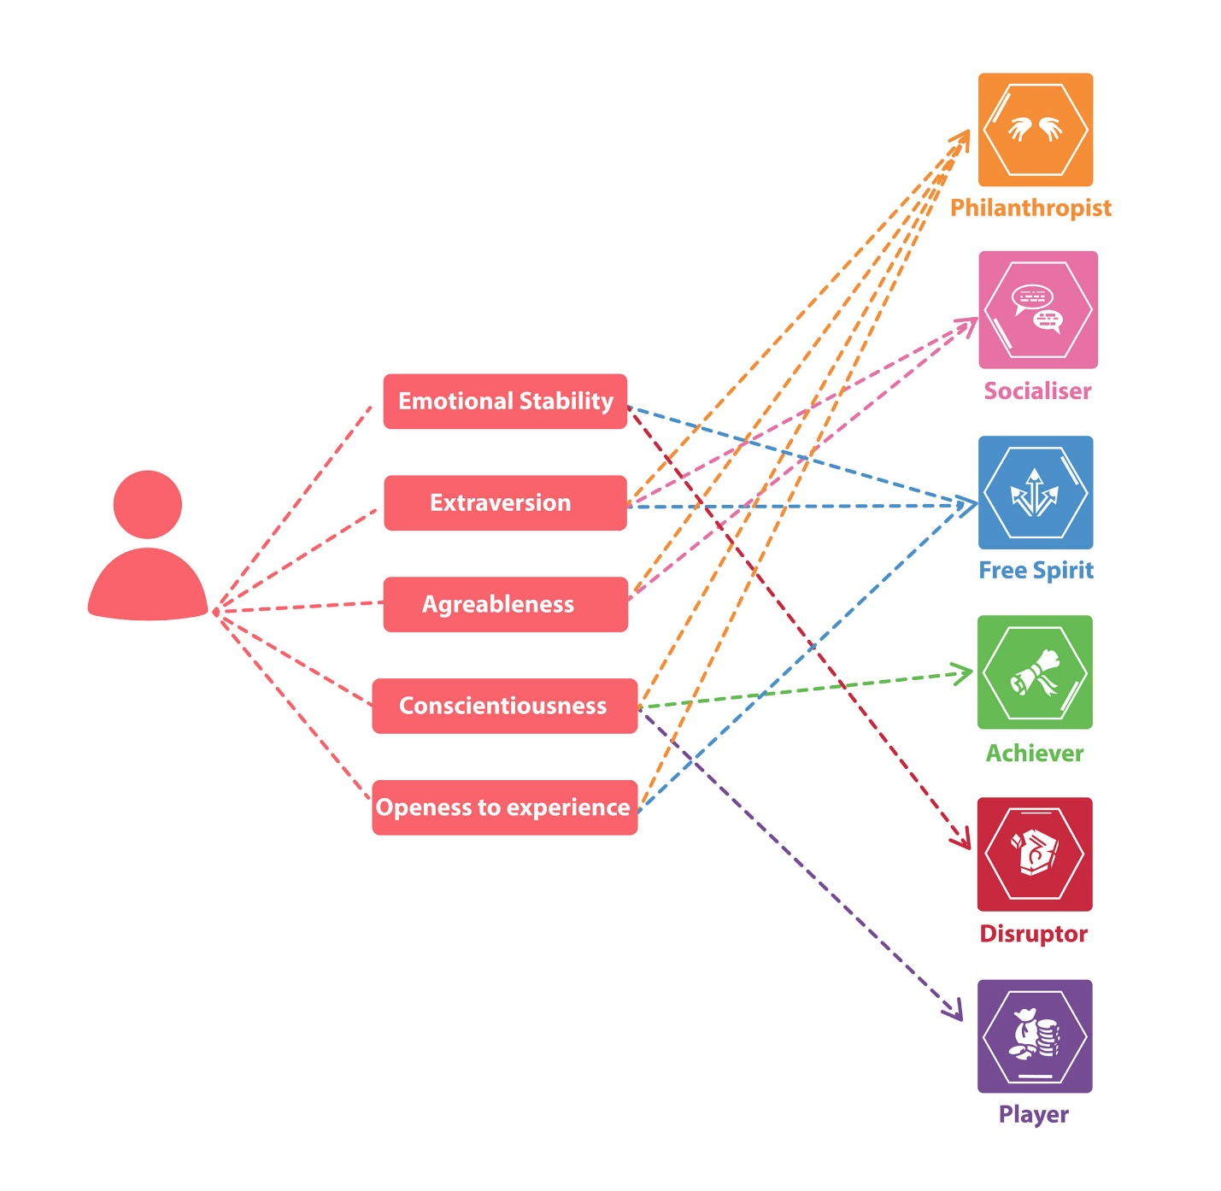

### Mapping Between Hexad and Game Elements

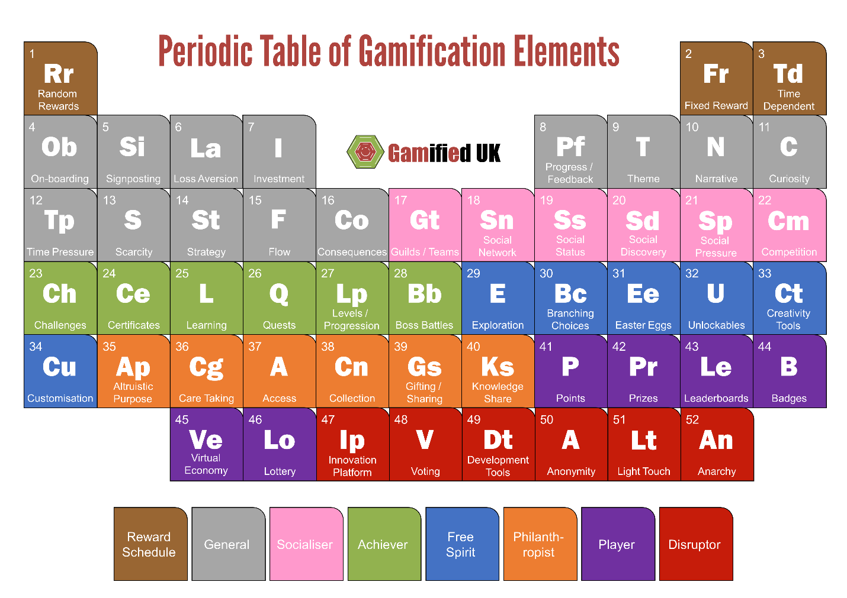

### Gamification User Types Hexad framework

classifies users as follows:

* **Philanthropists** who are altruistic and willing to give without expecting a reward.
* **Socializers** want to interact with others and create social connections.
* **Achievers** seek to progress within a system by completing tasks or prove themselves by tackling difficult challenges.
* **Free Spirits** are motivated by freedom to express themselves. They like to create and explore within a system.
* **Players** will do whatever to earn a reward within a system, independently of the type of the activity.
* **Disruptors** tend to disrupt the system either directly or through others to force negative or positive changes.

## IMPLEMENTATION TECHNOLOGY

### User Interface

Since this is a Web based application so it should provide a very User-friendly interface. Also, it should be easy to navigate without any obstructions. A decent and pleasant appearance with ease of navigation should help to users.

UI-1: Main page interface which includes brief description video about the website, and it also include control buttons to sign in.

UI-2: Sign in form using sign in form interface.

UI-3: in case you do not have an account, register using registration form interface which is used for registration for the first time with determining the registerer type.

Teachers UI

UI-4: creating new term.

UI-5: Creating a new Classroom by clicking the button of create classroom.

UI-6: Can sign in a Classroom using the classroom code.

After being in the specified classroom,

UI-7: can upload materials, create posts, assign new assessments, set grades, set deadlines, logout button.

UI-8: Interacting with students by having a shared chat.

UI-9: teacher can give feedback or report about students.

Parents UI

UI-10: Can view his/her own children only.

After Being in the specified classroom,

UI-11: View grades of their own child “children”, view rank, teacher report, logout button

Students UI

UI-12: can view their term courses and insert the specified code for each course.

UI-13: can view materials, grades, assessments, deadlines, upload assignment and exams.

UI-14: Interact with teacher using chatbot.

UI-14:

### Software Interface

The communication between client and server is asynchronous. This will help to handle a large amount of users simultaneously. The portal should support all major web browsers that will make it convenient for the user to access our system with ease. The back- end i.e. the database services will be used to a great extent and hence it will be quiet efficiently designed.

SI-1: developer responsibilities which are allow removing content, edit pages and user profiles.

SI-2: server interface which allows developers to control both database and websites overall, it may help to improve database connection and availability of the website.

### Hardware Interface

The hardware requirement at the user end is simple and the Portal will be available on the hardware that can run a basic simple browser, provided the hardware should be competent enough during peak times for the web servers.

HI-:1 Screen, PCS interfaces

### Used Technologies

Web Application

Front-end: CSS3, HTML5, Bootstrap 4,5, jQuery "Libraries", JavaScript.

Back-end: php "Laravel php framework", MySQL database "phpMyAdmin".

framework: - vue js, react js

Application Interface:

Since this is a Web based application so it should work on major browsers like Internet explorer, Mozilla Firefox, Google Chrome, Opera etc.

Safety and Security Constraints:

Since application is intended for the authenticated users only should be allowed to access the data. Also, any of anonymous people should not be able to access, edit, modify, or even see these data.

Chapter Three

# Requirements Gathering

## user classes and characteristics

**Students:** They are the people who studying in the school.

**Parent:** They are the guardians of the student.

**Teacher:** They are persons who teach a different subject

## Functional Requirement

### Functional requirement of teacher

**1) Teachers can register on the system**

* sign up new account
* enter full name
* enter password
* enter email
* enter gender
* verification
* If any field of register are missing student are not able to register a new account.
* After successful register student can choose his educational level and his courses he want to learn

**2)Teacher can login into their account after registration in the system**

* enter username
* enter password
* login

**3) Create classroom for courses**

* after login account
* press create classroom
* enter name for classroom or for course
* system give code to teacher
* teacher can send code to student or share it

**4)Assign classwork for student**

* Teacher press to assign new assignment after login account
* teacher set the deadline for each assignment
* if student assign after deadline it will be missed
* if student uploaded the assignment after deadline it will be late
* if student assign before deadline he can turn in his assignment
* after student turn in assignment teacher have the ability to make marks for each student

**5) Upload materials of course for student**

* after login teacher he can press upload new material
* upload can be files word document or videos
* after teacher finish upload student can download files from website to his laptop or computer

**6) Teacher can review the interaction of students to the website**.

* Teacher can know the number of the student who are interact on the classroom which is:
* who uploads the assignment
* who download or view the videos or word documents

**7) set result of student**

* teacher can set result after deadline of each assignment and after exams on classroom
* student can see their result on website

**8) Chat bot to answer specific question to the student, parent, if there is no answer all the actors can interact with each other**

* after student or parent login
* they can see a chat bot side of website
* student or parent can ask question throw chat bot
* system will respond automatically if there are unknown question it will pass to teachers of this course
* teachers respond as soon as possible

### Functional requirement of Student

**1) student can create free accounts.**

* Student enter their first name
* Student enter their last name
* Student choose their gender
* Student enter his age
* Student choose their username
* Student create their password
* Verification
* If any field of register are missing student are not able to register a new account.
* After successful register student can choose his educational level and his courses he want to learn.
* Students submit questionnaire to know their personality type.
* After that user have their username and password to login at any time.

**2) System is responsible for choosing the Gamification method for students by making a survey to ask about their personalities type.**

* After register there will be a questionnaire that let us to know the personality types of the student.
* According to the questionnaire we will make us know their beloved kind of gamification for them. And the system chooses from the lists of available personality types which are:
* General type (Progress / Feedback, Time Pressure)
* Schedules (Fixed Reward Schedule)
* Free Spirit (Branching Choices)
* Achiever (Certificates)
* Player (Leaderboards / Ladders, Badges / Achievements

**3) login to his account**

* Student enter their username
* Student enter their password
* If any field of login are missing Student are not able to register to their account.
* After login Student are in the home page of the website.

**4) Have access to upload their classwork**

* Student can review the assignments and download it by click the page of the assignments.
* After the student answer the assignment and want to upload it, he register the website by his account, then click to the page of the assignment and upload it.

**5) Showing the submission status of assignments.**

* After the students submit their assignment, the system will show to them that they submit the assignments.
* Also, they have the ability to edit and modify their assignments before the deadline.
* They have the ability to resubmit before the deadline.

**6) View their grades**.

* After the exams the system sent to students’ notifications that mark of the subject is appear.
* Student can register the website by his account, then click to the student grade page and view his mark.

**7) View the schedule:**

* Before view his schedule student must choose his educational level and register his courses.
* After the students register his courses, he can access his account, then click to the schedule page an view his schedule.

**8) Students have the ability to create favorite folders**.

* Click to the favorite page
* Upload some materials or their favorite hobbies.

**9) chat bot to answer specific questions to the students.**

* Click to the chat bot page.
* Write his question or his problem.
* The system will respond to his question.
* If there are any questions unknown for the system then, the questions will pass to actors (teachers) to respond on it as soon as possible.

**10) view the details including (Rank, Grades, Registered courses, and Feedback) of students**.

* Student can review his performance of their by having access on the Ranks of the exam by click on the page of rank.
* Student can review their grades by click on the page of grades.
* Student can find his feedback or performance or by click on the page of feedback.

**11) Notifications of deadlines for students.**

* Before one day of the deadline there is will be a reminder send to the students for who are not submit it.

**12) Students may submit a Questionnaire at the end of courses.**

* There will be a survey appeal at each of courses that student will feel free to submit it.

### Functional requirement of parents

**1)Parents can register free accounts.**

* Parents enter their first name
* Parents enter their last name
* Parents choose their gender
* Parents choose their username
* Parents create their password
* verification
* If any field of register are missing parents are not able to register a new account.
* After successful register Parents will determined their children by their username and their full name.
* After that user have their username and password to login at any time.

**2) Parents can login into their account after registration in the system**

* Parents enter their username
* Parents enter their password
* If any field of login are missing parents are not able to register to their account.
* After login parent are in the home page of the website.

**3) Review the details including (Rank, Grades, Registered courses, and Feedback) of their children.**

* Parents can review the performance of their children by having access on the Ranks of the exam by click on the page of rank.
* Parents can review the grades of their children by click on the page of grades.
* Parents can review the registered courses of their children by click on the page of registered courses.
* Parents can give their feedback of their children performance or on the website performance by click on the page of feedback.

**4) Parents can connect with the teachers through private chat on the system by click on the icon of chat bot they can ask for**

* Ask about how to enhance their children performance
* Ask for advice about how to take care of their children
* Also, can connect to the system for technical issues

## Nonfunctional Requirement

**1) Friendly UI for both, children, and parents by submitting feedback about the system.**

* There will be a feedback from the teachers and students and - parents about the UI of the system.
* After that use these feedbacks to enable us to enhance our website to be suitable for them

2**) Performance Requirements:**

* by search about the similar Apps. We found that the website loading time have to range by 2 to 5 seconds.

**3) Security Requirements:**

* Advanced password secure for login page by using hashing techniques and authentication.
* Encryption method that encrypts the two ways between data entered and data receiver “like End-to-end encryption”
* Make sure that is the used a database should be secured.
* Inactivity timeouts “by using session”.

**4) Usability.**

* Language is English which is suitable for all users.
* There are users feedback in the website which can make some analysis of the website.
* The user of the website can access the website from any laptop, pc, tablet and smartphones which the website will be a responsive website.

**5) Help:**

* That will be a page on the website that contain common question with specific answer to student, parents, and, teacher to guide them

Chapter four

# SOFTWARE DIAGRAMS

## Structural Diagrams

### Entity Relational Diagram (ERD)

Figure 4.1 1 ERD

### Class Diagram

Figure 4.1 2 Class Diagram

### Deployment diagram

Figure 4.1 3 Deployment Diagram

## Behavioral Diagrams

### Use Case

**Use case for student.**

4.2 1(use case)

**Use case for teacher.**

4.2 2 (use case cont(1))

**Use case for parent.**

4.2 3(use cse cont(2))

### State Chart

4.2 4(state chart)

4.2 5(state chart cont(1))

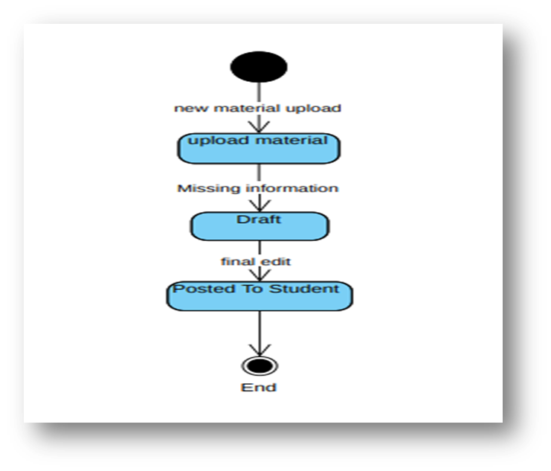

4.2 6(state chart cont(2))

### Activity Diagram

4.2 7(Activity diagram)

4.2 8(Activity diagram cont(1))

4.2 9(Actvity diagram cont(2))

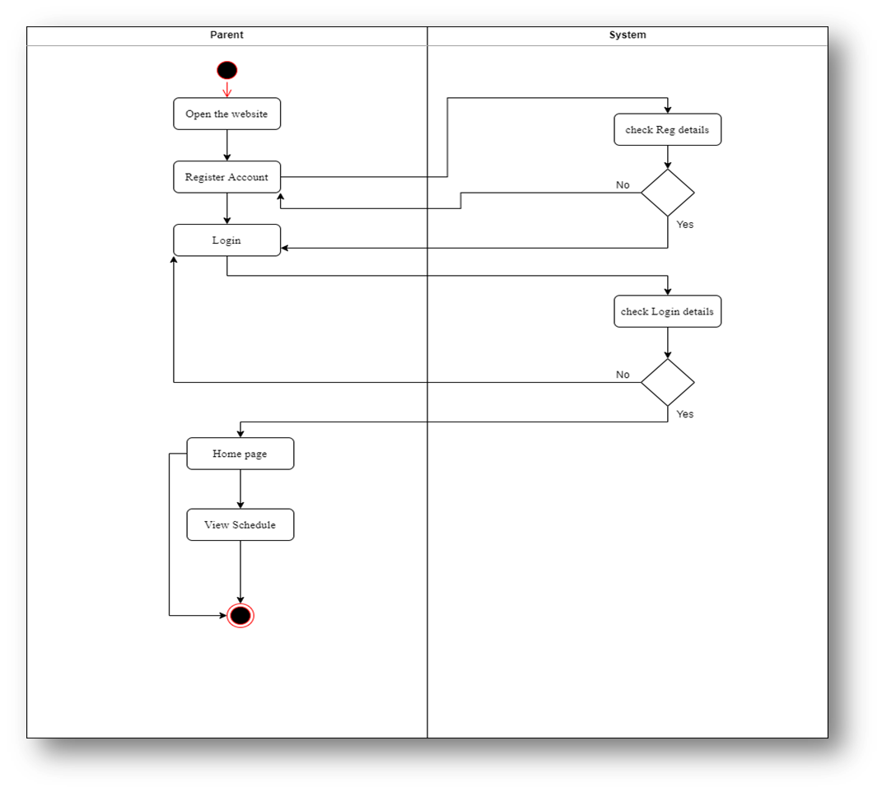

4.2 10 (Activity diagram cont(3))

4.2 11(Activity diagram cont(4))

4.2 12(Activity diagram cont(5))

4.2 13(Activity diagram cont(6))

4.2 14(Activity Diagram cont(7))

4.2 15(Activity Diagram cont(8))

4.2 16(Activity diagram cont(9))

4.2 17(Activity diagram cont(10))

4.2 18(Activity Diagram cont(11))

4.2 19(Activity Diagram cont(12))

4.2 20(Activity Diagram cont(13))

4.2 21(Activity Diagram cont(14))

4.2 22(Activity Diagram cont(15))

4.2 23(Activity diagram Cont(16))

4.2 24(Activity Diagram Cont(17))

4.2 25(Activity Diagram cont(18))

### Sequence Diagram

4.2 26(Sequence Diagram)

4.2 27(Sequence Diagram cont(1))

4.2 28(Sequence Diagram cont(2))

4.2 29(Sequence Diagram cont(3))

4.2 30(sequence Diagram cont(4))

4.2 31(Sequence diagram cont(5))

4.2 32(Sequence Diagram cont(6))

4.2 33(Sequence Diagram cont(7))

4.2 34(Sequence Diagram cont(8))

4.2 35(Sequence diagram cont(9))

'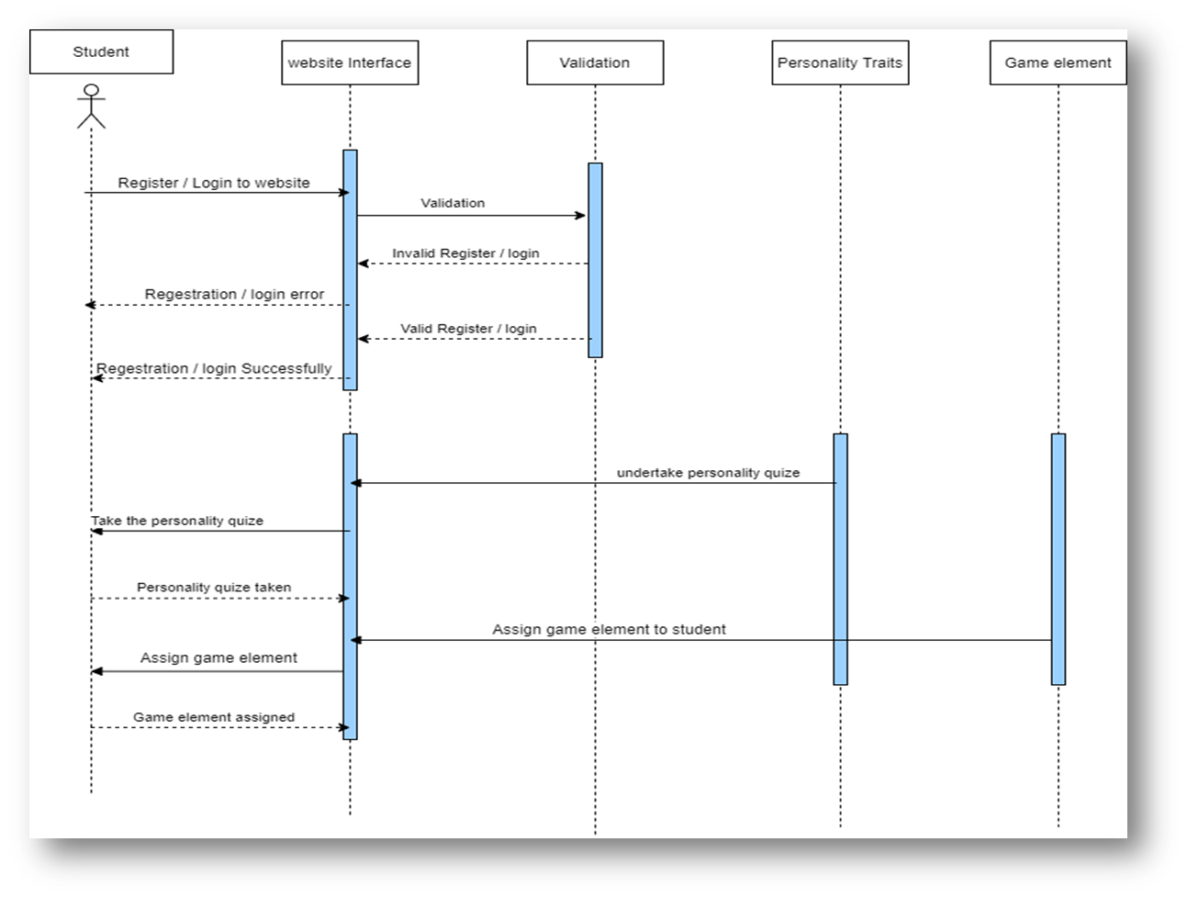

4.2 36(Sequence Diagram cont(10))

4.2 37(Sequence Diagram cont(11))

4.2 38(Squence Diagram cont(12))

Chapter Five

# Product Implementation

Chapter Six

# FUTURE WORK AND CONCLUSION

## Future work:

Recently we think a lot about the future of education and learning. Topics we are extremely passionate about. We are more convinced than ever that we´re on the brink of experiencing a massive and super exciting educational sea change. the teacher still mostly talks, and the student mostly listens. There will be no differences between learning in person and learning online. The communications architecture is still one-to-many. There will be no class scale. We want to lead this field among our competitors. We always keep in touch with what is new and useful to society in this field.

## Conclusion

E-learning is not just a change of technology. It is part of a redefinition of how we as a species transmit knowledge, skills, and values to students. Online Education has brought a positive impact in the lives of students, teacher, and parent. It has given an opportunity to take up additional courses along with their studies as per their convenience. Online education has also helped the faculty in the institutions to ask students to study some part of syllabus online which do not require much of classroom instructions. So, the online study helps the faculty to save time in which they can interact with the students more. The quality of education has improved by online courses and even it has become easy for students to refer the content as per their leisure. education increase even more and will be beneficial for students, professionals and also institutions.

**6.3 References**

1. <https://www.classcraft.com/>
2. <https://new.edmodo.com/>
3. <https://www.weareteachers.com/>
4. <https://www.e-learningforkids.org/>
5. <https://www.pbslearningmedia.org/>